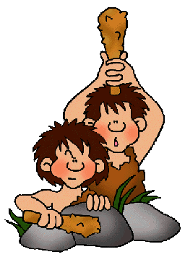
Early Humans Web Quest

Task Objective: Gain a fascinating insight into the lives of early people using the website: http://earlyhumans.mrdonn.org/

Go to Introduction & Geography link: http://earlyhumans.mrdonn.org/introduction.html

Then, fill in the blanks by reading.
In your study of early man there are going to be many new terms and words for you to learn. Here are four very important vocabulary words to start you out.
- Hominids is a kind of slang term among scientists. It means ____________ and anything that looks and acts like mankind.

- Fossils are remains of living things (__________, __________, __________) that have been turned into stone or have left an impression in the stone. Anything that man has made is ________ a fossil.

- Artifacts are remains of things that were _________, not remains of living things.

- Hunter/gatherer refers to how a group of people gets their food. They find it growing wild or hunt and fish for it. They _______ _______ _______ any food.

After, travel to Hunters & Gatherers link: http://earlyhumans.mrdonn.org/huntergatherer.html

- What is a hunter/gatherer? Hunter/gatherer refers to how a group of people get their food. They find it growing wild or hunt and fish for it. They do not grow any food. Another name for a hunter/gatherer is a ___________.

- As early humans left _________ and spread throughout the globe, they found fruits and nuts that were edible. They _________ seeds and roots. They became adept at catching ________. Fishing was done using spears, bow and arrow, nets, and even fish hooks. As time went on, some early humans built ________ and rafts to go out into deeper water to catch larger fish.

- Hunters mostly went after herd beasts such as deer, wooly mammoth, and saber-toothed tigers! They had bows and ________ tipped arrows, _______ spears, ______ knives and axes, and they built snares and pits to catch animals. Over time, early man learned how to preserve meat to help feed themselves during the long cold winters. During the __________ months, they would ________ the herds and hunt. During the __________ they ________ to their winter camps.
- It took a long time for man to settle down and learn how to plant and harvest crops. For _______ of years, man was a ________ and ________.

Next, click on Homo Habilis "Handy Man" link: http://earlyhumans.mrdonn.org/tools.html

This early man lived in __________.
- So how did early man survive? He had to use the things that _______ did not have, ________ and ________. Early man invented and created stone and ______ weapons and tools. With these tools, early man could kill and trap those animals he needed for food. With stone axes and spears, he could defend against those animals that thought he might be food. Since many of the tools he created were made out of ______ this is called the Stone Age.

- The Stone Age is considered to have begun about ______ million years ago, and ended sometime after the end of the last ice age about ______ thousand years ago.

- During the Stone Age, Homo Habilis appeared. These early people were mostly vegetarian, eating fruits, nuts, berries and occasionally fish and animals they hunted. They were not great hunters due to the crude construction of their spears and axes, but they did get the job done. Early man used the tools he created to hunt in groups for large animals such as wooly mammoths and wooly rinocerous.

- Homo Habilis did use ______ and made campfires, but these were probably started by finding something that was already burning from a _________ __________.

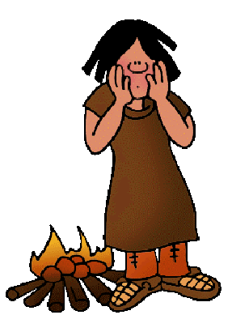

Learn about Homo Erectus "Upright Man" by clicking on the link: http://earlyhumans.mrdonn.org/fire.html

1,600,000 BCE to about 300,000 BCE
With the sea level lowered, early humans were able to cross ________ __________ between continents. They crossed into these new lands, probably following herds of animals or in search of food.

They were ______ users. They had stone axes and knives and were probably the first hunters as well as gatherers.

The discovery and use of fire was very important to early man for many reasons.

- First, they discovered most animals are _________ of fire. So a campfire gave some protection to the group or tribe.

- Second, they could camp in better locations. They no longer had to look for trees to climb into or rocks and cliffs to __________ under.

- Third, it kept them __________. This goes with the second reason. They could move into ________ climates and hunt the animals that lived there. They could then return to their campfire to warm up.

- Fourth, it was a __________ way of life. Cooked food is less likely to carry _________. These people began to cook their food consistently. As a result, it would have been easier for the young and the old to survive.

- Fifth, it was a more social grouping. They could now gather in larger groups, feeling safer and more secure. This allowed them to exchange _________.

- There were other reasons that having a fire was an improvement in their lives. Can you think of any?
_________________________________________________________________________________________________________________________________________________________________________________________________________________________________________________________

How do we know so much about Homo Erectus? There have been discoveries of the ____________ of Homo Erectus, most notably the one found near Peking (Beijing) China, which is called the Peking Man. _________________ have also found tools and weapons from this time period in other places, which gives a better understanding of how they lived and where they lived.

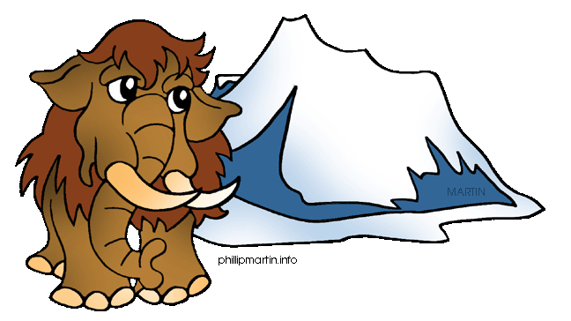

Learn more about the Ice Age by following the link:
http://earlyhumans.mrdonn.org/iceage.html

What is an ice age? An ice age is a period of time when much of earth's water is ________ in glaciers. Throughout time, the earth has experienced several ice ages. Things become cold, and then the weather warms up again. Each ice age takes many thousands of years to cycle. During an ice age, oceans become smaller and lower, as the water freezes into glaciers. This uncovers _______. Giant __________ of frozen ice also appeared during the last ice age over what would become vast rivers and seas.

During the last ice age, land bridges appeared between _________ and ________ and ________. Using these land bridges, early humans _________ out of Africa, probably following herds of animals.

Homo Sapiens"Wise Man" & Neanderthals
500,000 BCE to 30,000 BCE

http://earlyhumans.mrdonn.org/neanderthals.html
Homo _________ is different from Homo Erectus. The skull of Homo Sapiens is larger with a more pronounced forehead allowing the brain to be much larger.
Like Homo Erectus, Homo Sapiens was a hunter/gatherer, meaning that they gathered up much of their food from available vegetation and they did some hunting and fishing to eke out their diet. To do this they created stone and bone tools, needles and fish hooks. They tanned animal skins to make clothing and boots.

One of the earliest discoveries of early man was found under the ground of a Tal, or small hill, near the village of Neander. Thus we get the Neandertal man or Homo Neandertalensis. You might also see it spelled as Neanderthal. Either spelling is ___________ and each is used in noted archeology. The skeleton discovered was of a male. Archeologists first thought that Neanderthal was the link between ape and man since the skeleton showed a being that ________ with bent knees, a thick neck and head stuck out forward much like an ape. As scientific techniques improved, it was found that Neanderthal was actually an _______ man who had disfiguring arthritis, which caused him to be bent into the shape he was.

Later discoveries showed that Neanderthal man was actually taller then modern humans with a larger skull (and larger brain), and very strong (thick bones). From remains found, scientists have discovered that they lived in caves and had fires in which they cooked their food. They were good hunters.

Another interesting fact about Neandertal is that they _________ their dead. They also had some sort of ceremony because they painted the bodies of the dead.

Neandertals disappeared around 30,000 BCE. We don't know if they were killed off by another branch of Homo Sapiens or if they intermingled with other groups and gradually merged with them. But disappear they did.

Want to find out more about Early Man’s Clothing? Click the link: http://earlyhumans.mrdonn.org/clothing.html

The use of clothing helped man survive the ice age. In the winter months and in areas with a colder climate, early man to keep warm by making clothing from the ________ of ___________. In summer months and warmer climates, clothing consisted of woven ________ or bark.

- Neanderthal man was probably the first to make ____________. They tanned animal skins to make clothing and boots.
- Cro-Magnon invented ___________. They used needles for many purposes including sewing. They made boots, tunics and other garments out of _________, woven plants, and bark. They strung together ___________ made from shells, bone, and animal teeth.
What were Early Man’s Homes like? Find out here:
http://earlyhumans.mrdonn.org/homes.html

TREES & SHELTERS: Very early humans learned to stay away from caves as shelters. Caves were often already occupied by ____________ animals. Instead, they looked for _________ to climb into, or rocks and cliffs to shelter under. The discovery of _______ had a huge affect on early humans. A fire allowed them to pick where they camped. Animals were afraid of fire. And fire could be used to drive animals out of caves.

CAVES: From remains found, scientists have discovered that Neanderthals lived in ________ and had fires in which they cooked their food. Neanderthals preferred caves as sleeping places and temporary _________. They were good ___________. They removed any dangerous animals, and then moved in. Neanderthals, like other early people, were hunters and gatherers. They did ______ plant crops. They _________ food and followed the herds.

HUTS: Some early humans, like Cro-Magnon Man, had two homes, one they brought with them, and one they left behind them in a more ____________ location. These early people were hunters and gatherers. In the summer months, while following the herds, these early people lived in easy to pack and set up _________ or tee-pees. The summer tents were set up by either stringing them between two ________, or by covering some sticks tied together with the tanned ________ of animals. During the winter months, they lived in larger more permanent type _______. The winter huts were usually in a permanent location and were built much sturdier. They would be roomy enough for a ___________ to stay in. They were also made from tanned hides that had been sewn together and wrapped around ____________ which had been placed into __________ that they dug. They had an __________ in the top to let out smoke, and were weighted at the bottom with rocks or dirt to keep them anchored during ______________.

Learn more about Cave Paintings & Rock Art by following the link:
http://earlyhumans.mrdonn.org/caveart.html

- Why did Cro-Magnon man cover the walls and ceilings of hidden caves with paintings by many different people? Was it to aid in hunting or teaching? We just don't know. How did they find these caves? They painted in the same caves, so they must have known where they were. The ________ around these caves was hard to reach. Yet, Cro-Magnon painters sought out these caves. The entrances to the stone caves were ________, ________, and _______. The painters had to crawl or squirm through them to get to the large natural chambers in the cave where they painted their pictures. The painters had to bring their light (a torch or spoon lamp) and their paints, while crawling. It must have been very important to these early people to add their art to the art already in the cave.

- The painting done by early man was not done in charcoal, but in naturally occurring pigments such as _______ (iron oxide) or ________ (manganese). The ___________ were drawn with attention to detail, but the people were usually _________ figures. Many of these early man artists also drew outlines of their ________. Was this a way of signing their art?

- Interestingly enough, these caves and their paintings were _______ found by archeologists. The first caves with cave paintings were found in __________. Some ____________, playing in the woods, discovered the entrance to a _______, long forgotten. The entrance was __________ by a tree. Once the first cave had been found, and its importance realized, people started looking for more caves and found them. It is very likely that more caves with more cave paintings are still waiting to be found.

Watch this YouTube video about the Lascaux Cave: https://youtu.be/nYhmq3vo7aY
Describe what you see here: ________________________________________________________________________________________________________________________________________________________________________________________________________________________________________________________________________________________________________________

