MLK Quotes
1. “We must accept finite disappointment, but never lose infinite hope.”
2. “Darkness cannot drive out darkness; only light can do that. Hate cannot drive out hate; only love can do that.”
3. “Forgiveness is not an occasional act. It is a permanent attitude.”
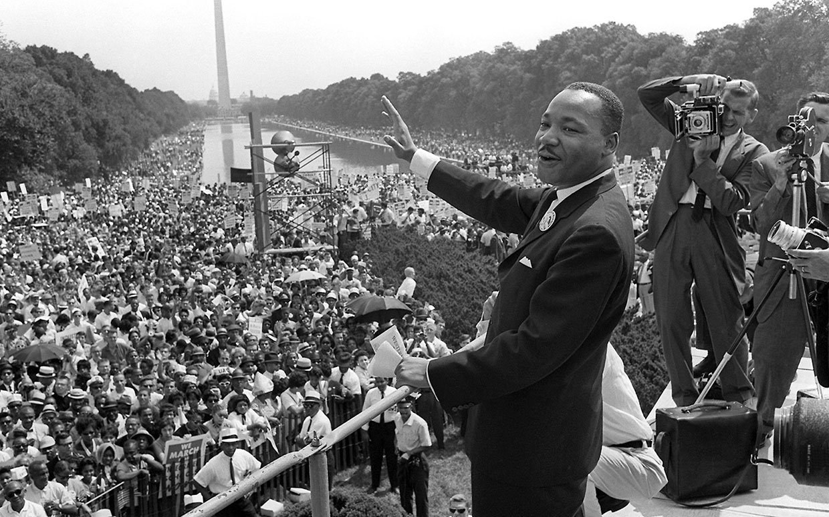(Getty Images)
4. “I have decided to stick with love. Hate is too great a burden to bear.”
5. “Faith is taking the first step even when you don’t see the whole staircase.”
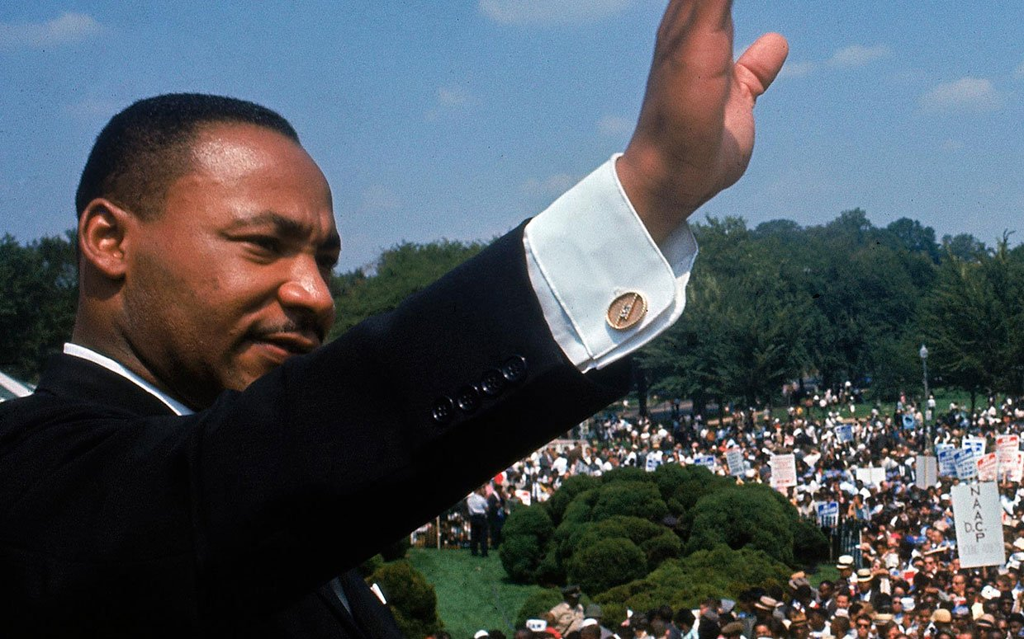
6. “Life’s most persistent and urgent question is, ‘What are you doing for others?'”
7. “Never succumb to the temptation of bitterness.”
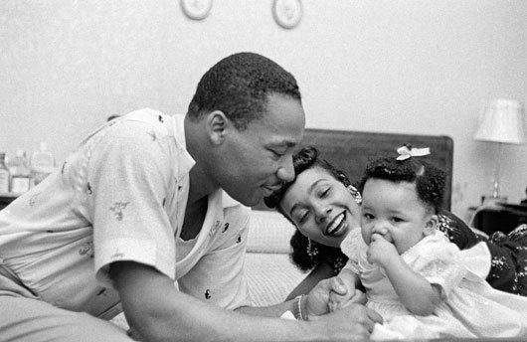King, his wife, Coretta Scott, and their first-born child, Yolanda, shown here at home in Montgomery, Alabama in 1956. (Getty Images)
8. “Our lives begin to end the day we become silent about things that matter.”
9. “We may have all come on different ships, but we’re in the same boat now.”
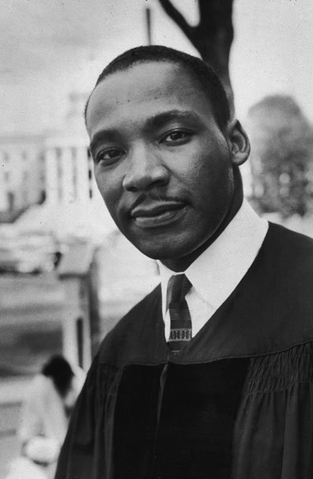
10. “The ultimate measure of a man is not where he stands in moments of comfort and convenience, but where he stands at times of challenge and controversy.”
11. “Change does not roll in on the wheels of inevitability, but comes through continuous struggle.”
12. “Love is the only force capable of transforming an enemy into friend.”
13. “There comes a time when one must take a position that is neither safe, nor politic, nor popular, but he must take it because conscience tells him it is right.”
14. “Let no man pull you so low as to hate him.”
15. “If you can’t fly then run, if you can’t run then walk, if you can’t walk then crawl, but whatever you do you have to keep moving forward.”
16. “Intelligence plus character—that is the goal of true education.”
17. “Out of the mountain of despair, a stone of hope.”
18. “The time is always right to do what is right.”
19. “Be a bush if you can’t be a tree. If you can’t be a highway, just be a trail. If you can’t be a sun, be a star. For it isn’t by size that you win or fail. Be the best of whatever you are.”
20. “We’ve got some difficult days ahead. But it really doesn’t matter with me now because I’ve been to the mountaintop… I’ve looked over and I’ve seen the promised land. I may not get there with you. But I want you to know tonight that we as a people will get to the promised land.”
21. “For when people get caught up with that which is right and they are willing to sacrifice for it, there is no stopping point short of victory.”
22. “I believe that unarmed truth and unconditional love will have the final word in reality. This is why right, temporarily defeated, is stronger than evil triumphant.”
23. “True peace is not merely the absence of tension; it is the presence of justice.”
24. “There is nothing more tragic than to find an individual bogged down in the length of life, devoid of breadth.”
25. “Shallow understanding from people of good will is more frustrating than absolute misunderstanding from people of ill will.”
26. “A lie cannot live.”
27. “There can be no deep disappointment where there is not deep love.”
28. “Man must evolve for all human conflict a method which rejects revenge, aggression and retaliation. The foundation of such a method is love.”
29. “There comes a time when people get tired of being pushed out of the glittering sunlight of life’s July and left standing amid the piercing chill of an alpine November.”
30. “We must develop and maintain the capacity to forgive. He who is devoid of the power to forgive is devoid of the power to love. There is some good in the worst of us and some evil in the best of us. When we discover this, we are less prone to hate our enemies.”
31. “Nonviolence is absolute commitment to the way of love. Love is not emotional bash; it is not empty sentimentalism. It is the active outpouring of one’s whole being into the being of another.”
32. “We are not makers of history. We are made by history.”
33. “Rarely do we find men who willingly engage in hard, solid thinking. There is an almost universal quest for easy answers and half-baked solutions. Nothing pains some people more than having to think.”
34. “We must build dikes of courage to hold back the flood of fear.”
35. “Let us not seek to satisfy our thirst for freedom by drinking from the cup of bitterness and hatred.”
36. “Man must evolve for all human conflict a method which rejects revenge, aggression and retaliation. The foundation of such a method is love.”
37. “Hate is just as injurious to the hater as it is to the hated. Like an unchecked cancer, hate corrodes the personality and eats away its vital unity. Many of our inner conflicts are rooted in hate. This is why psychiatrists say, “Love or perish.” Hate is too great a burden to bear.”
38. “Power without love is reckless and abusive, and love without power is sentimental and anemic. Power at its best is love implementing the demands of justice, and justice at its best is power correcting everything that stands against love.”
39. “In some not too distant tomorrow the radiant stars of love and brotherhood will shine over our great nation with all their scintillating beauty.”
40. “We shall match your capacity to inflict suffering by our capacity to endure suffering. We will meet your physical force with soul force. Do to us what you will. And we shall continue to love you.”
41. “If one loves an individual merely on account of his friendliness, he loves him for the sake of the benefits to be gained from the friendship, rather than for the friend’s own sake. Consequently, the best way to assure oneself that love is disinterested is to have love for the enemy-neighbor from whom you can expect no good in return, but only hostility and persecution.”
42. “That’s love, you see. It is redemptive, and this is why Jesus says love. There’s something about love that builds up and is creative. There is something about hate that tears down and is destructive. So love your enemies.”
43. “You know, a lot of people don’t love themselves. And they go through life with deep and haunting emotional conflicts. So the length of life means that you must love yourself. And you know what loving yourself also means? It means that you’ve got to accept yourself.”
44. “All we say to America is, ‘Be true to what you said on paper.’ If I lived in China or even Russia, or any totalitarian country, maybe I could understand the denial of certain basic First Amendment privileges, because they hadn’t committed themselves to that over there. But somewhere I read of the freedom of assembly. Somewhere I read of the freedom of speech. Somewhere I read of the freedom of the press. Somewhere I read that the greatness of America is the right to protest for right.”
45. “You can kill the dreamer, but you can’t kill the dream.”
46. “I want to be the white man’s brother, not his brother in law.”
47. “Even though we face the difficulties of today and tomorrow, I still have a dream.”
48. “A right delayed is a right denied.”
49. “Freedom is never voluntarily given by the oppressor; it must be demanded by the oppressed.”
50. “The hottest place in Hell is reserved for those who remain neutral in times of great moral conflict.”
51. “We must learn to live together as brothers or perish together as fools.”
52. “The quality, not the longevity, of one’s life is what is important.”
53. “A genuine leader is not a searcher for consensus but a molder of consensus.”
54. “The moral arc of the universe bends at the elbow of justice.”
55. “I am not interested in power for power’s sake, but I’m interested in power that is moral, that is right and that is good.”

